Mrs. Ratnamala Sudhakar Katkar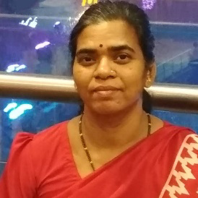

Art Teacher (Assistant Teacher)

Art Master, M.V.A, M.A, GD Art, ATD, HTC

Email ID: [ratnamalaskatkar1116@gmail.com](mailto:ratnamalaskatkar1116@gmail.com)